QKN1 Task 3: Financial Data Analysis and Visualization Using Python
Course: Analytics Programming — D598
Student: Dotun Oduwale

Introduction
This report presents the final stage of analysis for a small investment company managing an equity fund consisting of U.S.-based companies. Building upon Task 1 and Task 2, this task explains how the Python program was implemented and communicates insights through customized data visualizations. The objective is to clearly convey financial performance patterns to stakeholders using structured analysis and visual evidence.

A. Explanation of Python Code (Task 2)
The Python program was developed and executed in a Jupyter Notebook environment using the Pandas and Matplotlib libraries to perform structured financial data analysis.
The dataset was successfully imported into a Pandas DataFrame, and initial data validation steps were performed to ensure data integrity. This included checking for missing values and identifying duplicate records. A duplicate check using the duplicated() function confirmed that no duplicate rows were present in the dataset.
To support comparative financial analysis, the dataset was grouped by the Business State column using the groupby() function. Descriptive statistics, including mean, median, minimum, and maximum values, were calculated for all relevant numeric financial variables. These aggregated results were stored in a separate DataFrame for clear analytical interpretation.
Businesses with negative Debt-to-Equity ratios were filtered using conditional logic to identify companies that may represent higher financial risk. These filtered records were reviewed separately to support risk-focused insights.
A key component of the analysis involved calculating the Debt-to-Income ratio, defined as the ratio of Total Long-Term Debt to Total Revenue. To ensure computational accuracy and prevent runtime errors, a conditional approach was implemented to explicitly handle divide-by-zero scenarios. Specifically, when Total Revenue was equal to zero, the calculation was not performed; instead, a NaN (Not a Number) value was assigned using NumPy (np.nan). This was implemented using conditional logic (e.g., np.where() or equivalent), ensuring that undefined mathematical operations did not distort the dataset or cause execution failures.
The calculated Debt-to-Income ratio was then appended as a new column to the original dataset, allowing it to be used in subsequent analysis and visualization. Finally, the transformed dataset was reviewed to confirm successful integration of all computed metrics.

B. Customized Data Visualizations
Four customized data visualizations were created to communicate financial insights effectively:
- Average Revenue by State: illustrates revenue concentration across geographic regions.
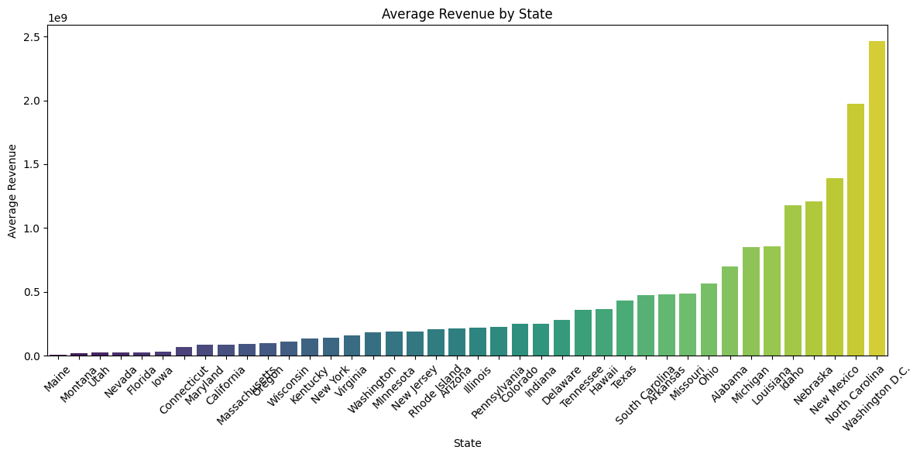
- Debt-to-Equity Ratio Distribution: highlights variability and potential outliers in financial leverage.
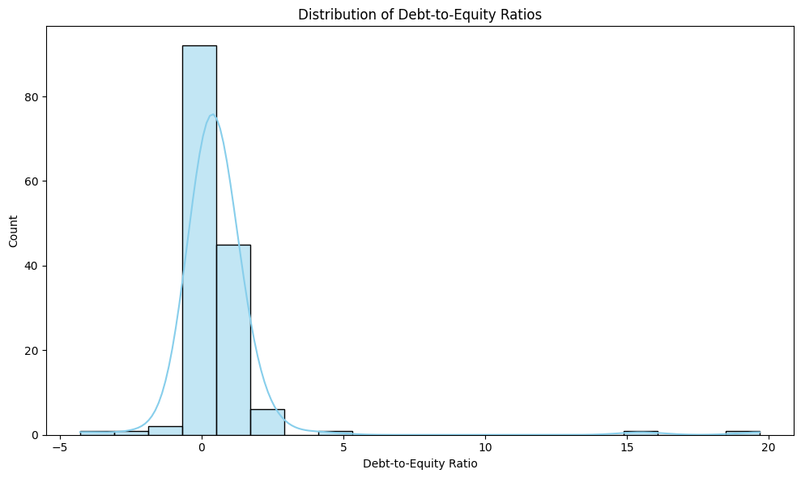
- Debt-to-Income vs Total Revenue: examines the relationship between leverage and revenue performance.
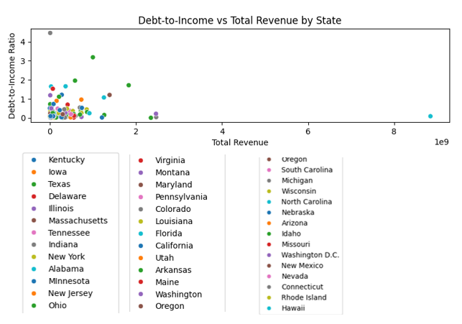
- Companies by State: shows the distribution of companies across different states.
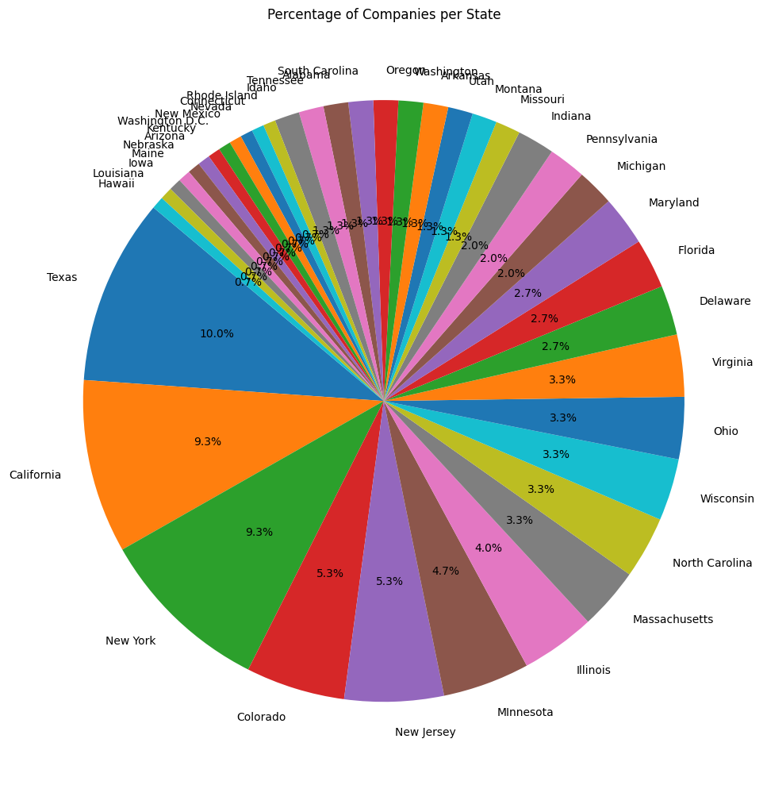

C. Explanation of Visualization Creation
The customized data visualizations were created using the Matplotlib and Seaborn libraries in Python, with data preparation and transformation performed using Pandas.
For the Average Revenue by State visualization, the dataset was grouped using the groupby() function on the Business State column, and the mean of Total Revenue was calculated. The results were sorted and plotted using a Seaborn bar chart (sns.barplot) with a defined figure size, color palette, rotated x-axis labels, and a descriptive title to enhance readability.
The Debt-to-Equity Ratio Distribution was visualized using a histogram (sns.histplot) with 20 bins and a kernel density estimate (KDE) curve to better understand the distribution and identify potential outliers. Axis labels and layout adjustments were applied to ensure clarity.
For the Debt-to-Income vs Total Revenue analysis, a scatter plot (sns.scatterplot) was created using the calculated Debt-to-Income ratio and Total Revenue. The data points were color-coded by Business State using the hue parameter, and a legend was positioned outside the plot area to improve visibility.
The Companies by State visualization was generated using a pie chart. The value_counts() function was used to calculate the number of companies per state, and the results were displayed using plt.pie() with percentage labels and a defined starting angle for better visual presentation.
Across all visualizations, customization techniques such as figure sizing (plt.figure()), titles (plt.title()), axis labels (plt.xlabel(), plt.ylabel()), color palettes, legends, and layout adjustments (plt.tight_layout()) were applied to ensure the visuals are clear, professional, and suitable for stakeholder communication.

D. Output Evidence
Screenshots from the Jupyter Notebook execution demonstrate successful data processing and visualization outputs, including dataset loading, statistical summaries, calculated ratios, and graphical results.

E. Sources and References (APA Style)
No external sources were used in the development of this project. All program logic, pseudocode, and analysis were created independently based on the concepts learned during the Analytics Programming (D598) course.

F. Conclusion
This project demonstrates effective use of Python for financial data analysis and visualization. Through structured code implementation and customized visualizations, key financial insights were clearly communicated to stakeholders. The analysis supports informed decision-making for portfolio evaluation and future fund rebalancing.

G. Professional Communication Statement
This report has been prepared using clear, concise, and professional language appropriate for both academic and stakeholder audiences. The content is logically structured, with consistent terminology and accurate grammar, spelling, and punctuation throughout. Additionally, all visual elements are clearly presented and effectively support the analytical findings and conclusions.

